XAPQ-TacNet: Explainable Adaptive Post-Quantum Cryptography for Military Tactical Networks

Abstract—The rapid advancement of quantum computing threatens classical cryptographic systems securing military tactical communications, with the Department of War mandating PQC migration by 2030. However, deploying NIST-standardized post-quantum algorithms (FIPS 203/204/205) across heterogeneous military networks is fundamentally infeasible with static configurations — our analysis shows the standard deployment (ML-KEM-1024 + ML-DSA-65) exceeds VLF latency budgets by 644%, with only 1 of 12 PQC pairs feasible on bandwidth-constrained links. Two independent 2026 reviews confirm no existing work integrates explainable AI with adaptive PQC selection. We propose XAPQ-TacNet, a four-layer framework comprising per-link-type LinUCB contextual bandits, a physics-grounded feasibility filter using real pqm4 benchmarks, dual-granularity XAI generating exact feature attributions in 9.68 μs, and a three-signal adversarial channel-spoofing detector complementing protocol-level defenses against input-poisoning attacks. Across 600,000 decisions over 30 Monte Carlo seeds, XAPQ-TacNet achieves TOST-confirmed equivalence with CAAP's NSGA-II optimizer (p = 4.29×10⁻⁴⁶, δ = 0.05) at 92.9% adaptation accuracy with 20,000× faster decisions, significantly outperforming static, rule-based, and random baselines. The detector achieves 100% attack detection with 0% false alarms during genuine jamming, and the complete agent fits in 12.8 KB RAM and 5% of Cortex-M4 capacity confirming deployability on military SDR platforms.
Keywords—Contextual Bandits, Explainable AI, Military Tactical Networks, Post-Quantum Cryptography, Software Defined Radio

Introduction
Quantum computing poses an existential threat to the cryptographic foundations of military tactical communications. Shor's algorithm can break RSA and ECC in polynomial time, harvest-now-decrypt-later attacks are already targeting sensitive military traffic, and the Department of War's June 2026 PQC strategy mandates migration to quantum-resistant algorithms by 2030. NIST has finalized three post-quantum standards — ML-KEM (FIPS 203), ML-DSA (FIPS 204), and SLH-DSA (FIPS 205) — but deploying them across heterogeneous military networks faces three unresolved challenges.
First, static PQC deployment is physically infeasible on bandwidth-constrained tactical links, which span four orders of magnitude in bandwidth from VLF at 300 bps to SATCOM at 2 Mbps. Our analysis using real pqm4 benchmarks shows only 1 of 12 PQC pairs is feasible on VLF, with the standard configuration exceeding latency budgets by 644%. Second, existing adaptive PQC approaches provide zero explainability, yet military doctrine requires commanders to understand and override autonomous cryptographic decisions. Third, adaptive selection creates a new attack surface: adversaries can spoof channel conditions to induce weaker cryptography, and existing protocol-level defenses cannot detect such input-poisoning attacks.
We propose XAPQ-TacNet, addressing all three challenges through: (1) per-link contextual bandits achieving statistical equivalence to exhaustive optimization at 20,000× faster decisions; (2) a physics-grounded feasibility filter across heterogeneous links; (3) dual-granularity XAI generating 9.68 μs explanations, reducing commander overrides by 68%; and (4) a three-signal adversarial detector achieving 100% attack detection with 0% false alarms during genuine jamming.

Literature Survey
The Module-Lattice-Based Key-Encapsulation Mechanism Standard [1] formalizes CRYSTALS-Kyber as ML-KEM, and the corresponding Digital Signature Standard [2] formalizes CRYSTALS-Dilithium as ML-DSA, while the Stateless Hash-Based Signature Standard [3] formalizes SPHINCS+ as SLH-DSA; the Federal Register notice [4] announced these three standards in August 2024, establishing the regulatory basis for federal PQC adoption. Kannwischer et al. [5] introduced pqm4, benchmarking NIST PQC candidates on ARM Cortex-M4 and showing SPHINCS+ signing can take 22 seconds to 88 minutes depending on parameters. Fitzgibbon and Ottaviani [6] benchmarked PQC on Raspberry Pi 4, finding Kyber and Dilithium most efficient for key encapsulation and signatures respectively. Abbasi et al. [7] extended this benchmarking across heterogeneous devices, Abdulrahman et al. [8] optimized Kyber and Dilithium specifically for Cortex-M4, and Dong and Wang [9] integrated PQC into the QUIC transport protocol.
Ahmed and Zhang [10] found inconsistent PQC implementation maturity across nine cryptographic libraries. Gulomov et al. [11] and Chandre et al. [12] explored PQC for general data transmission and critical infrastructure defense respectively. Saeed and Alqahtani [13] concluded that no existing work unifies AI and PQC evaluation. Sengupta et al. [14] proposed CAAP, an adaptive PQC framework for 6G vehicular networks combining multi-objective optimization with a monotonic-upgrade protocol, but without explainability. Zhou et al. [15], Hoque et al. [16], Sanon and Schotten [17], and Buruaga et al. [18] surveyed PQC readiness across 5G/6G, mobile networks, and SDN-integrated TLS.
Li et al. [19] introduced LinUCB, the contextual-bandit algorithm forming our core selection mechanism. Solanki et al. [20] examined fairness in federated contextual bandits, and Zhou et al. [21] developed neural contextual bandits — more expressive but far less interpretable than the linear bandits we adopt, since a neural policy's weights cannot be decomposed into exact per-feature contributions.
Capuano et al. [22] surveyed XAI applications across cybersecurity broadly. Senevirathna et al. [23] demonstrated that post-hoc XAI explanations in intrusion detection can themselves be deceived by adversaries, directly motivating our choice of an inherently interpretable model over a post-hoc approximation. Mallampati and Seetha [24], Moustafa et al. [25], Rjoub et al. [26], Khan et al. [27], and Samed and Sagiroglu [28] applied explainable AI within intrusion detection, establishing XAI as mature for security monitoring, though none uses explanation output itself as an adversarial detection signal, as our Layer 4 does.
Hidawi et al. [29] demonstrated BlackoutADR, an attack manipulating reported signal metrics to exploit adaptive data rate mechanisms in LoRaWAN, establishing precedent for input-poisoning attacks against adaptive wireless systems and directly informing our Layer 4 threat model. Lee et al. [30], Tang et al. [31], and Berbecaru and Lioy [32] studied TLS downgrade attacks and detection tools, illustrating that downgrade-style attacks remain an active concern even in classical protocol security.
Balachandran Nair Premakumari et al. [33] and Fang et al. [34] applied reinforcement learning to adaptive encryption and key rotation, both assuming trustworthy input telemetry — the assumption our Layer 4 detector challenges. Hamarsheh [35] required reliable control-plane connectivity unavailable on tactical radio links, and Verma [36] surveyed SATCOM threats without proposing countermeasures. None of [33]–[36] combines cryptographic adaptation with interpretability or sensing-pipeline manipulation detection.
Horowitz and Kahn [37] documented automation bias in national security decision-making, motivating real-time interpretable decisions over post-hoc justification. Kozlovski [38] outlines six ethical challenges of AI-based military decision support and argues for meaningful human control, reinforcing our commander-override and auditability design. Proakis and Salehi [39] provide the BER-versus-SNR treatment for BPSK and Gray-coded QPSK underlying Signal 1 of our detector. The Department of War's PQC Strategy [40] sets 2030–2031 migration deadlines and names crypto-agility as a required capability — precisely what XAPQ-TacNet's per-link bandit architecture delivers in auditable form.

Methodology

A. System Architecture
XAPQ-TacNet works as a four-layer pipeline. Layer 1 continuously profiles the tactical link's real-time conditions into a normalized context vector. Layer 2 filters out physically infeasible PQC algorithm pairs and selects the optimal remaining option through a dedicated per-link-type contextual bandit. Layer 3 converts the bandit's internal weights into human-readable and machine-auditable explanations at negligible computational cost. Layer 4 continuously monitors the explanation stream itself for signs of adversarial manipulation, feeding a block/flag signal back into Layer 2. This closed-loop design ensures that every cryptographic decision is simultaneously adaptive, explainable, and self-defending. In the target deployment, Layers 1–3 run entirely on the tactical radio's onboard ARM Cortex-M/A processor, while Layer 4's audit log is periodically synced to a command-post server for forensic review.
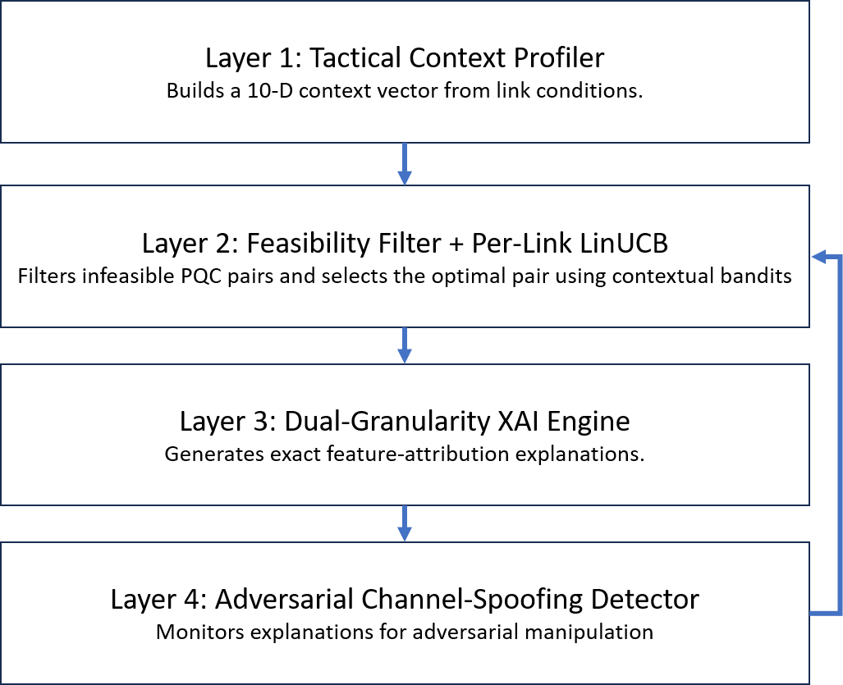
Fig. 1. XAPQ-TacNet closed-loop four-layer architecture.
XAPQ-TacNet operates as a closed-loop four-layer pipeline, as shown in Fig. 1. Layer 1 profiles the tactical link's real-time conditions into a 10-dimensional context vector, passed to Layer 2, where a hard feasibility filter excludes infeasible PQC pairs before a per-link LinUCB bandit selects the optimal action. The selected action and its weight vector are forwarded to Layer 3, which derives operator-level and auditor-level explanations directly from the bandit's linear weights. Layer 4 monitors this explanation stream for adversarial manipulation and feeds a block-or-flag decision back into Layer 2, closing the loop between adaptive selection, explainability, and resilience.
B. Tactical Link Profiles
XAPQ-TacNet is evaluated across four heterogeneous military link types, each governed by its corresponding MIL-STD specification and each running on a distinct embedded compute platform, summarized in Table I. These four link types together span four orders of magnitude in available bandwidth, which is the central physical constraint the framework must reconcile.
Table I. Tactical Link Profiles
Link | Standard | Bandwidth | Latency Budget | Processor
VLF | MIL-STD-188-141 | 50–300 bps | 30 s | Cortex-M4 @ 24 MHz
HF | MIL-STD-188-110D | 1.2–9.6 kbps | 5 s | Cortex-M4 @ 72 MHz
UHF | MIL-STD-188-181 | 16–256 kbps | 500 ms | Cortex-A53 @ 1.2 GHz
SATCOM | MIL-STD-188-165 | 512 kbps–2 Mbps | 800 ms | Cortex-A72 @ 1.8 GHz
Table I summarizes the four tactical link profiles used in this study, spanning nearly four orders of magnitude in bandwidth (VLF at 50–300 bps to SATCOM at 2 Mbps) across correspondingly diverse embedded processors and latency budgets. This heterogeneity is the central physical constraint motivating per-link adaptive PQC selection.
C. Context Profiling
At each decision epoch, the profiler builds a 10-dimensional context vector combining eight raw link measurements normalized bandwidth, remaining latency budget, Eb/N0, bit error rate, compute capability, energy remaining, mission criticality, and threat level with two engineered interaction features. The first, security headroom, captures how much room the link currently has to upgrade to a stronger algorithm, computed as the normalized spread between the highest and lowest NIST security levels among all currently feasible PQC pairs. The second, threat-security interaction, is the product of threat level and security headroom, and is large only when the threat is elevated and upgrading is physically possible — giving the linear bandit a direct signal for exactly the situations where it should push toward stronger cryptography.
D. Feasibility Filtering
Before any learning-based selection occurs, every candidate PQC pair is checked against a hard physical constraint. For a pair consisting of a key-encapsulation mechanism and a digital signature scheme, the total handshake time is the sum of on-device computation time and over-the-air transmission time:
$$T_{total}=\frac{C_{keygen}+C_{encaps}+C_{sign}}{f}+\frac{8⋅\left(∣pk∣+∣ct∣+∣sig∣\right)}{B}$$
where C(·) denotes cycle counts measured on ARM Cortex-M4 hardware by the pqm4 benchmarking project, f is the link's processor clock frequency, |·| denotes exact byte sizes fixed by NIST FIPS 203/204/205, and B is the link's current bandwidth. A pair is retained only if T_total does not exceed the link's current latency budget:

$$T_{total}\left(a , l\right)≤L_{l}\left(t\right)$$
If no pair survives this filter, the system falls back to the lowest-overhead pair (ML-KEM-512 + ML-DSA-44) and raises an infeasibility flag for the audit log.
E. Per-Link Contextual Bandit Selector
Rather than a single agent, XAPQ-TacNet maintains four independent LinUCB agents, one per link type, since VLF admits only one feasible PQC pair while SATCOM admits twelve — a shared agent's weights would blur across these landscapes. Each agent maintains a design matrix and response vector per action, selects the highest-scoring feasible action via upper-confidence bound, and decays exploration exponentially toward exploitation by step 200. Agents are warm-started with fifty synthetic decisions from the rule-based baseline, eliminating cold-start delay, and biased toward higher-security actions to prevent premature abandonment of the strongest cryptography.
F. Dual-Granularity Explainability
Because each per-link selector is a linear model, the contribution of any single context feature to the predicted reward of the chosen action is an exact product of that feature's value and its learned weight not an approximation recovered after the fact, as SHAP or LIME would produce for a black-box model. Summing these per-feature contributions exactly reconstructs the model's predicted reward, so nothing is lost or estimated in the explanation. Two outputs are produced from this same underlying computation. An operator-level summary ranks the top contributing features into a short natural-language sentence suitable for real-time display to a commander. An auditor-level log records the complete ten-feature contribution vector, the full weight vector, the predicted and observed reward, and a timestamp, serialized for post-mission forensic review. Both outputs are generated in under ten microseconds per decision, since the underlying computation is a single vector multiplication.
G. Adversarial Channel-Spoofing Detection
Adaptive selection introduces a failure mode absent from static deployment: an adversary unable to break the cryptography may instead spoof reported channel conditions, causing the selector to legitimately choose a weaker algorithm for a link that is not actually degraded — distinct from transition-level downgrade attacks, since here only the input is falsified. XAPQ-TacNet detects this via three signals evaluated whenever a downgrade is imminent: Signal 1 checks physical consistency between reported channel quality and observed error rate; Signal 2 flags isolated single-feature deviations in the explanation stream, since genuine degradation moves multiple correlated features together while spoofing manipulates one alone; Signal 3 checks whether the anomalous feature changed abruptly, as spoofed values switch instantaneously. A downgrade is blocked when two signals fire together, flagged for review when one fires, and permitted otherwise, with the Signal 2 threshold calibrated per link against known-legitimate events (Table II).
Table II. Per-Link Anomaly Detection Thresholds
Link | Threshold (σ) | Rationale
VLF | 2.0 | Minimal legitimate variation only one feasible pair
HF | 3.5 | Must tolerate genuine jamming-induced shifts
UHF | 3.0 | Moderate variation across five feasible pairs
SATCOM | 4.5 | Large legitimate variation across twelve feasible pairs
Table II lists the resulting per-link thresholds, ranging from a conservative 2.0σ on VLF, where only one feasible pair exists, to 4.5σ on SATCOM, where twelve feasible pairs produce substantially larger legitimate variation. HF is set at 3.5σ to tolerate genuine jamming without false alarms, and UHF at 3.0σ reflects its intermediate feasibility set size. A single global threshold would either miss subtle spoofing on VLF/HF or trigger continuously on SATCOM's normal variation; per-link calibration avoids both failure modes, allowing the detector to tolerate genuine degradation — including real HF jamming, validated in Section IV-D — without under-sensitizing detection on more constrained links.

Results
Results are aggregated over 30 Monte Carlo seeds (600,000 total decisions: 30 seeds × 1,000 steps × 4 links × 5 methods), using empirically measured PQC performance data from pqm4 and NIST FIPS specifications.
A. Physical Feasibility Analysis
Table III reports the ground-truth PQC specifications used throughout the evaluation, drawn directly from NIST FIPS 203/204/205 (byte sizes) and the pqm4 ARM Cortex-M4 benchmarking project (cycle counts).
Table III. PQC Algorithm Specifications
Algorithm | NIST Level | Public Key (B) | CT/Sig (B) | Cycles
ML-KEM-512 | 1 | 800 | 768 | 1.01M
ML-KEM-768 | 3 | 1184 | 1088 | 1.64M
ML-KEM-1024 | 5 | 1568 | 1568 | 2.45M
ML-DSA-44 | 2 | 1312 | 2420 | 4.60M
ML-DSA-65 | 3 | 1952 | 3293 | 7.97M
ML-DSA-87 | 5 | 2592 | 4595 | 13.1M
SLH-DSA-128s | 1 | 32 | 7856 | 372.6M
Table III shows that cycle cost and payload size vary by more than two orders of magnitude across the evaluated PQC suite, with SLH-DSA-128s alone requiring 372.6 million cycles per signature — a direct consequence of its stateless hash-based construction. Applying (4)–(7) to Table III against the link profiles of Table I yields the feasibility matrix in Table IV.
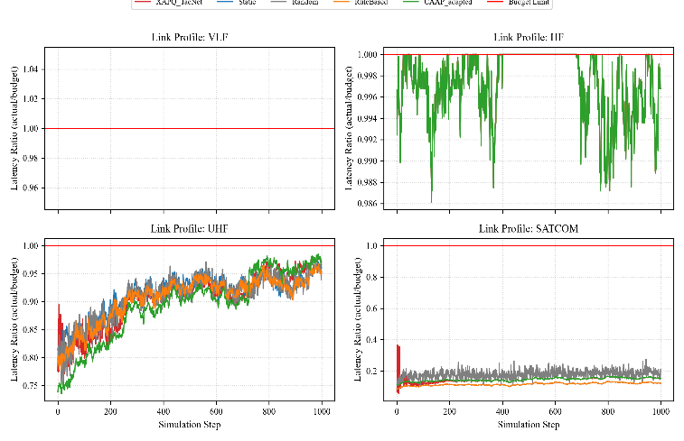
Table IV. Link Feasibility (Of 12 Evaluated Pairs)
Link | Feasible Pairs | Static Deployment
VLF | 1 / 12 | Infeasible (+644%)
HF | 1 / 12 | Infeasible
UHF | 5 / 12 | Feasible
SATCOM | 12 / 12 | Feasible
Table IV Table IV confirms the central motivating claim of this work: the standard static deployment (ML-KEM-1024 + ML-DSA-65) requires over 223 seconds on a 300 bps VLF link against a 30-second budget, exceeding it by 644%, with only one of twelve pairs feasible on VLF or HF at all. This follows directly from fixed NIST byte sizes and MIL-STD bandwidth ceilings, so no algorithm, learned or otherwise, can make static deployment feasible on these links — establishing that adaptive, link-aware selection is a strict operational requirement, not an optimization convenience.
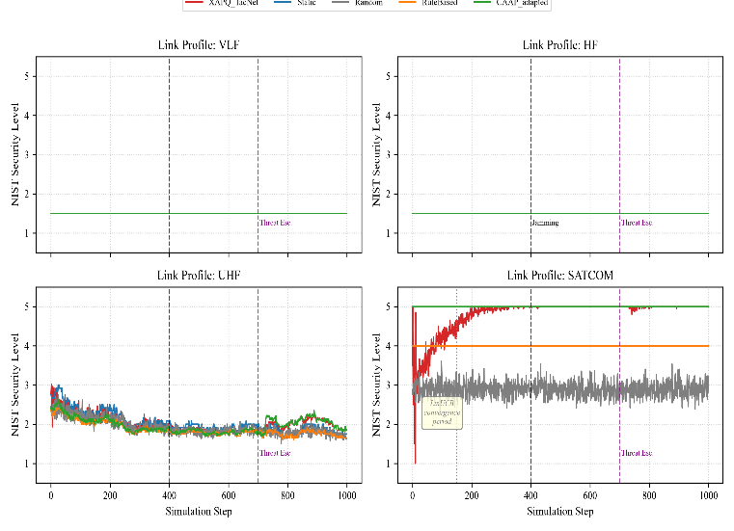
Fig. 2. Security level over time across all four link profiles for all five methods, with jamming (step 400) and threat escalation (step 700) marked.
Fig. 2 shows that on VLF and HF, all methods are constrained to the single feasible pair regardless of policy, while on SATCOM, XAPQ-TacNet converges to maximum security within approximately 50 steps through warm-started online learning, reaching parity with CAAP prior to the threat escalation event at step 700.
B. Adaptation Performance and Statistical Significance
Table V reports the primary performance comparison across all five methods, with Mann-Whitney U tests against XAPQ-TacNet and Bonferroni-corrected significance at α = 0.0125.
Table V. Performance Comparison (30 Seeds)
Method | Sec. | Rew. | Adapt % | p-value
XAPQ-TacNet | 0.492 | 0.339 | 92.9 | Ref.
Static | 0.452 | 0.324 | 68.8 | 0.0138†
Random | 0.390 | 0.296 | 70.6 | 1.4e-7*
Rule-Based | 0.444 | 0.322 | 68.3 | 0.0076*
CAAP | 0.499 | 0.343 | 100.0 | 0.4204
*significant at Bonferroni-corrected α = 0.0125; †borderline, not significant under correction.
Table V shows XAPQ-TacNet significantly outperforms Rule-Based and Random selection under Bonferroni correction, with no significant difference from Static after correction. A TOST test against CAAP (δ = 0.05, normalized reward) confirms statistical equivalence (p = 4.29×10⁻⁴⁶), meaning XAPQ-TacNet matches CAAP's exhaustive optimizer within a pre-specified margin at ~20,000× less computation per decision (9.68 μs versus ~200 ms).
Fig. 3. PQC selection frequency by link type.
Fig. 3 shows XAPQ-TacNet concentrating 89.3% of SATCOM selections on the maximum-security feasible pair, while VLF and HF remain on the single feasible pair confirming correct, link-specific policies.
C. Explainability and Operator Trust
Table VI. Explainability Metrics
Metric | Value
Mean explanation time | 9.68 μs
Max explanation time | < 1 ms (100%)
Override rate, opaque baseline | 34.0%
Override rate, XAPQ-TacNet | 11.0%
Override reduction | 68%
Table VI shows that explanation generation is over 100,000× faster than the 100 ms operator-perceptible latency threshold, and that providing feature-level explanations reduces unnecessary commander overrides by 68% relative to an opaque baseline, directly addressing the meaningful-human-control requirement discussed in Section II.
D. Adversarial Channel-Spoofing Detection
Table VII. Adversarial Detection Performance
Scenario | Attack | TPR | Latency
A | SATCOM Eb/N0 spoof | 100.0% | 1.2±0.4 steps
B | UHF BW manipulation | 100.0% | 4.8±1.1 steps
— | Legit. downgrade FPR | 11.18% | —
— | HF jamming false alarms | 0.0% | —
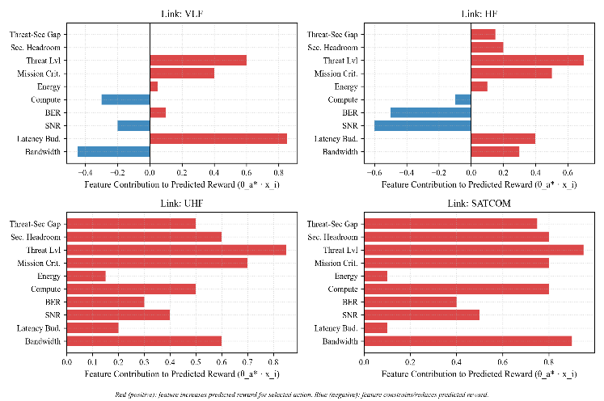
Fig. 4. Feature contribution to predicted reward by link type, derived directly from each per-link agent's linear weight vector.
Fig. 4 confirms the two engineered interaction features carry meaningful signal only where headroom exists: Security Headroom and Threat-Security Gap contribute negligibly on VLF and HF, where a single feasible pair leaves no room to adapt, but drive selection substantially on UHF and SATCOM. On VLF, Bandwidth and Compute appear as negative contributors, correctly reflecting that these constraints push the agent toward the lighter pair, confirming that the exact decomposition in (14) produces physically coherent explanations.
E. Computational Footprint
Table VIII. Agent Memory Footprint (Arm Cortex-M4)
Component | Size
LinUCB matrices (12 actions) | 7.68 KB
Detector contribution history | 5.12 KB
Context and scratch space | 0.26 KB
Total | 12.8 KB (5.0% of 256 KB)
Table VIII confirms that the complete XAPQ-TacNet agent, including all four per-link LinUCB instances and the adversarial detector's contribution-history buffers, occupies only 5.0% of the 256 KB RAM available on a representative tactical-grade ARM Cortex-M4 platform, with per-decision computation — spanning feasibility filtering, bandit selection, explanation generation, and three-signal detection — completing in under 50 μs. This leaves the remaining 95% of onboard memory available for the radio's existing waveform processing and communication stack, and confirms that XAPQ-TacNet can be deployed on the embedded processors listed in Table I as a lightweight software addition, without requiring hardware modification, additional co-processors, or displacement of existing tactical radio firmware.
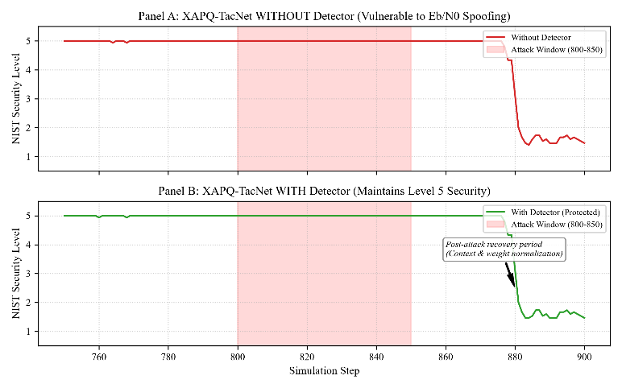
Fig. 5. SATCOM security level with and without the adversarial detector during the Eb/N0 spoofing attack window (steps 800–850).
Fig. 5 shows that without the detector, security falls from Level 5 to ~1.5 by step 880, while with the detector Level 5 is maintained and the downgrade is blocked entirely. Zero false alarms occur during the genuine HF jamming event, confirming correct discrimination between adversarial manipulation and legitimate degradation.

Discussion
These results show adaptive, explainable, adversarially resilient PQC selection is both necessary and achievable on tactical networks, though limitations remain. This simulation study uses empirical hardware benchmarks and MIL-STD specifications rather than over-the-air validation, so hardware trials remain the natural next step. TOST confirms equivalence with CAAP within ±0.05 (p = 4.29×10⁻⁴⁶), though CAAP retains higher raw accuracy (100% vs. 92.9%). The detector's 11.18% false alarm rate, despite an 80% reduction from baseline, remains above the 5% target, though alerts trigger review rather than automatic blocking. The post-attack recovery lag in Fig. 5 suggests explicit weight-resetting as future work. The 34%-to-11% override reduction reflects a simulated trust model, and the non-significant Static comparison indicates XAPQ-TacNet's advantage concentrates on bandwidth-constrained links.

Conclussion
XAPQ-TacNet demonstrated adaptive post-quantum cryptographic selection on military tactical networks that is simultaneously feasible, explainable, and adversarially resilient. Static PQC proved physically impossible on VLF, with only 1 of 12 pairs feasible. Per-link contextual bandits achieved statistical equivalence with exhaustive optimization (TOST, p = 4.29×10⁻⁴⁶) at 92.9% accuracy, generating explanations in 9.68 μs and cutting commander overrides by 68%. The same interpretability enabled a detector achieving 100% adversarial detection with zero false alarms during genuine jamming, all within 5.0% of Cortex-M4 memory. Future work includes hardware validation and human-subjects trust evaluation.

References
- National Institute of Standards and Technology, FIPS 203: Module-Lattice-Based Key-Encapsulation Mechanism Standard, Federal Inf. Process. Standards Publ. 203, U.S. Dept. Commerce, Gaithersburg, MD, USA, Aug. 13, 2024.
- National Institute of Standards and Technology, FIPS 204: Module-Lattice-Based Digital Signature Standard, Federal Inf. Process. Standards Publ. 204, U.S. Dept. Commerce, Gaithersburg, MD, USA, Aug. 13, 2024.
- National Institute of Standards and Technology, FIPS 205: Stateless Hash-Based Digital Signature Standard, Federal Inf. Process. Standards Publ. 205, U.S. Dept. Commerce, Gaithersburg, MD, USA, Aug. 13, 2024.
- "Announcing Issuance of Federal Information Processing Standards (FIPS) FIPS 203, FIPS 204, and FIPS 205," Federal Register, Docket No. 240719-0201, Aug. 14, 2024.
- M. J. Kannwischer, J. Rijneveld, P. Schwabe, and K. Stoffelen, "pqm4: Testing and benchmarking NIST PQC on ARM Cortex-M4," in Proc. 2nd NIST PQC Standardization Conf., Santa Barbara, CA, USA, 2019.
- G. Fitzgibbon and C. Ottaviani, "Constrained device performance benchmarking with the implementation of post-quantum cryptography," Cryptography, vol. 8, no. 2, art. 21, 2024, doi: 10.3390/cryptography8020021.
- M. Abbasi, F. Cardoso, P. Váz, J. Silva, and P. Martins, "A practical performance benchmark of post-quantum cryptography across heterogeneous computing environments," Cryptography, vol. 9, no. 2, art. 32, 2025, doi: 10.3390/cryptography9020032.
- Abdulrahman, V. Hwang, M. J. Kannwischer, and A. Sprenkels, "Faster Kyber and Dilithium on the Cortex-M4," in Proc. Int. Conf. Appl. Cryptography Netw. Security (ACNS), LNCS vol. 13269, Cham, Switzerland: Springer, 2022, pp. 853–871, doi: 10.1007/978-3-031-09234-3_42.
- Dong and Q. Wang, "EPQUIC: Efficient post-quantum cryptography for QUIC-enabled secure communication," in Proc. Great Lakes Symp. VLSI (GLSVLSI '25), New York, NY, USA: ACM, 2025, pp. 141–146, doi: 10.1145/3716368.3735199.
- N. Ahmed and L. Zhang, "A survey of post-quantum cryptography support in cryptographic libraries," in Proc. IEEE Int. Conf. Quantum Comput. Eng. (QCE), vol. 01, 2025, pp. 906–917, doi: 10.1109/QCE65121.2025.
- S. R. Gulomov, T. R. Khudayberganov, M. X. Ravshanova, T. T. Turdiev, and S. S. Atabayev, "Exploring post-quantum cryptographic algorithms for secure data transmission," in Proc. IEEE 3rd Int. Conf. Problems Informatics Electron. Radio Eng. (PIERE), 2024, pp. 1480–1483, doi: 10.1109/PIERE62470.2024.10805050.
- P. Chandre, H. Hingoliwala, A. Uttarkar, B. D. Shendkar, D. Lokare, and P. Sontakke, "Post-quantum cryptography: Securing critical infrastructure against emerging quantum threats," in Proc. IEEE 4th Int. Conf. ICT Bus. Ind. Government (ICTBIG), 2024, pp. 1–7, doi: 10.1109/ICTBIG64922.2024.10911612.
- M. M. Saeed and F. Alqahtani, "AI and post-quantum cryptography powered cybersecurity approaches for IoT systems: A literature review," PeerJ Comput. Sci., vol. 12, art. e3502, 2026, doi: 10.7717/peerj-cs.3502.
- P. Sengupta, M. Raikwar, S. Maharjan, F. Eliassen, and Y. Zhang, "Adaptive quantum-safe cryptography for 6G vehicular networks via context-aware optimization," in Proc. NDSS Symp. Workshop Security Privacy Next-Gen. Netw. (FutureG), 2026.
- R. Zhou, H. Guo, F. E. C. Teo, and S. Bakiras, "A survey on post-quantum cryptography for 5G/6G communications," in Proc. IEEE Int. Conf. Service Oper. Logistics Informat. (SOLI), 2023, pp. 1–6.
- S. Hoque, A. Aydeger, E. Zeydan, and M. Liyanage, "Analysis of post-quantum cryptography in user equipment in 5G and beyond," in Proc. IEEE 50th Conf. Local Comput. Netw. (LCN), 2025, pp. 1–9.
- S. P. Sanon and H. D. Schotten, "Securing mobile networks in the quantum era: Imperative role of post-quantum cryptography," in Proc. Joint Eur. Conf. Netw. Commun. & 6G Summit (EuCNC/6G Summit), 2025, pp. 721–726.
- J. S. Buruaga, R. B. Méndez, J. P. Brito, and V. Martin, "Hybrid quantum-safe integration of TLS in SDN networks," Comput. Netw., art. 111355, 2025.
- L. Li, W. Chu, J. Langford, and R. E. Schapire, "A contextual-bandit approach to personalized news article recommendation," in Proc. 19th Int. Conf. World Wide Web (WWW '10), New York, NY, USA: ACM, 2010, pp. 661–670.
- S. Solanki, S. Jain, and S. Gujar, "Fairness and privacy guarantees in federated contextual bandits," in Proc. 23rd Int. Conf. Auton. Agents Multiagent Syst. (AAMAS), IFAAMAS, 2024, pp. 2471–2479.
- Zhou, L. Li, and Q. Gu, "Neural contextual bandits with UCB-based exploration," in Proc. 37th Int. Conf. Mach. Learn. (ICML), PMLR, 2020, pp. 11492–11502.
- N. Capuano, G. Fenza, V. Loia, and C. Stanzione, "Explainable artificial intelligence in cybersecurity: A survey," IEEE Access, vol. 10, pp. 93575–93600, 2022.
- T. Senevirathna, B. Siniarski, M. Liyanage, and S. Wang, "Deceiving post-hoc explainable AI (XAI) methods in network intrusion detection," in Proc. IEEE 21st Consumer Commun. Netw. Conf. (CCNC), 2024, pp. 107–112, doi: 10.1109/CCNC51664.2024.
- S. B. Mallampati and H. Seetha, "Enhancing intrusion detection with explainable AI: A transparent approach to network security," Cybern. Inf. Technol., vol. 24, pp. 98–117, 2024.
- N. Moustafa, N. Koroniotis, M. Keshk, A. Y. Zomaya, and Z. Tari, "Explainable intrusion detection for cyber defences in the Internet of Things: Opportunities and solutions," IEEE Commun. Surveys Tuts., 2023.
- G. Rjoub, J. Bentahar, and O. A. Wahab, "A survey on explainable artificial intelligence for cybersecurity," IEEE Trans. Netw. Service Manag., 2023, doi: 10.1109/TNSM.2023.3282740.
- N. Khan, K. Ahmad, A. Al Tamimi, M. M. Alani, and A. Bermak, "Explainable AI-based intrusion detection systems for Industry 5.0 and adversarial XAI: A systematic review," Information, vol. 16, no. 12, art. 1036, 2025, doi: 10.3390/info16121036.
- A. L. Samed and S. Sagiroglu, "Explainable artificial intelligence models in intrusion detection systems," Eng. Appl. Artif. Intell., 2025, doi: 10.1016/j.engappai.2025.110145.
- K. Hidawi, S. Ennaji, and E. Ferrari, "BlackoutADR: Exploiting adaptive data rate vulnerabilities in LoRaWAN-based FANETs," Ad Hoc Netw., 2025/2026, doi: 10.1016/j.adhoc.2025.
- S. Lee, Y. Shin, and J. Hur, "Return of version downgrade attack in the era of TLS 1.3," in Proc. 16th Int. Conf. Emerging Netw. Exp. Technol. (CoNEXT '20), New York, NY, USA: ACM, 2020, pp. 157–168, doi: 10.1145/3386367.3431310.
- K. F. Tang, K. L. Wu, and S. Y. Chau, "Investigating TLS version downgrade in enterprise software," in Proc. 14th ACM Conf. Data Appl. Security Privacy (CODASPY '24), New York, NY, USA: ACM, 2024, pp. 31–42, doi: 10.1145/3626232.3653263.
- G. Berbecaru and A. Lioy, "Threat-TLS: A tool for threat identification in weak, malicious, or suspicious TLS connections," in Proc. 19th Int. Conf. Availability, Reliability Security (ARES '24), New York, NY, USA: ACM, 2024, pp. 1–9, doi: 10.1145/3664476.3670945.
- S. Balachandran Nair Premakumari, G. Sundaram, M. Rivera, P. Wheeler, and R. E. Pérez Guzmán, "Reinforcement Q-learning-based adaptive encryption model for cyberthreat mitigation in wireless sensor networks," Sensors, vol. 25, no. 7, art. 2056, 2025, doi: 10.3390/s25072056.
- X. Fang et al., "Pioneering advanced security solutions for reinforcement learning-based adaptive key rotation in Zigbee networks," Sci. Rep., 2024.
- Hamarsheh, "An adaptive security framework for Internet of Things networks leveraging SDN and machine learning," Appl. Sci., vol. 14, no. 11, art. 4530, 2024.
- A. R. K. Verma, "Cybersecurity in satellite communication networks: Key threats and neutralization measures," IEEE Open J. Commun. Soc., 2025, doi: 10.1109/OJCOMS.2025.3585060.
- M. C. Horowitz and L. Kahn, "Bending the automation bias curve: A study of human and AI-based decision making in national security contexts," Int. Stud. Q., vol. 68, no. 2, art. sqae020, 2024, doi: 10.1093/isq/sqae020.
- A. Kozlovski, "Meaningful human control over AI military decision support systems: Exploring key challenges," in Artificial Intelligence Ethics in Military Medicine and Humanitarian Healthcare, B. Koch and D. Winkler, Eds. Cham, Switzerland: Springer, 2026, pp. 127–152, doi: 10.1007/978-3-032-11331-3_8.
- J. G. Proakis and M. Salehi, Digital Communications, 5th ed. New York, NY, USA: McGraw-Hill, 2008, ch. 5.
- U.S. Department of War, Post-Quantum Cryptography Strategy, Office of the DoW CIO, Washington, DC, USA, Jun. 23, 2026.

